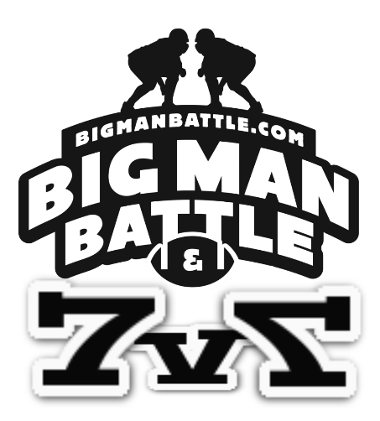
7v7 Rules and Regulations. Mouthpiece and Helmet required.
This is 7v7 on had touch football.
All passing only. Shuttle passes are allowed, as well as bubble screens etc. No double passes
Offense will have QB, and 5 Receivers, while defense will have a non rushing 7 defenders.
The offense will use a QB Tee to take snaps from and will time at 4 seconds after the ball is retrieved from Tee. If a QB is in shotgun formation then he may pull the QB Tee back off the line to take it from the snap there. All other members are and must be In a regular football set. Two Receivers must be on the ball and none covered up. (Regular football Rules)

Penalties are all 5 yards except
Pass interference-nearest first down, or at the referee’s discretion.
Personal foul- game ejection if violent, or referee’s discretion. Not allowed to play remainder of that game.

All first downs are premarked on 10 yards. (40, 30, 20,10 yard lines)
Four downs to get a first.
Scoring a touchdown is worth 6 pts
Extra point from 10 is 2 pts
Extra point from 3 is 1pt
Interception is worth 3 pts, ( No return will be allowed)
An Interception on an extra point attempt does not count for points for defense.

